**AI BASED DISCOURSE FOR BANKING INDUSTRY**

**Team ID:** PNT2022TMID27784

**CREATE IBM SERVICE:**

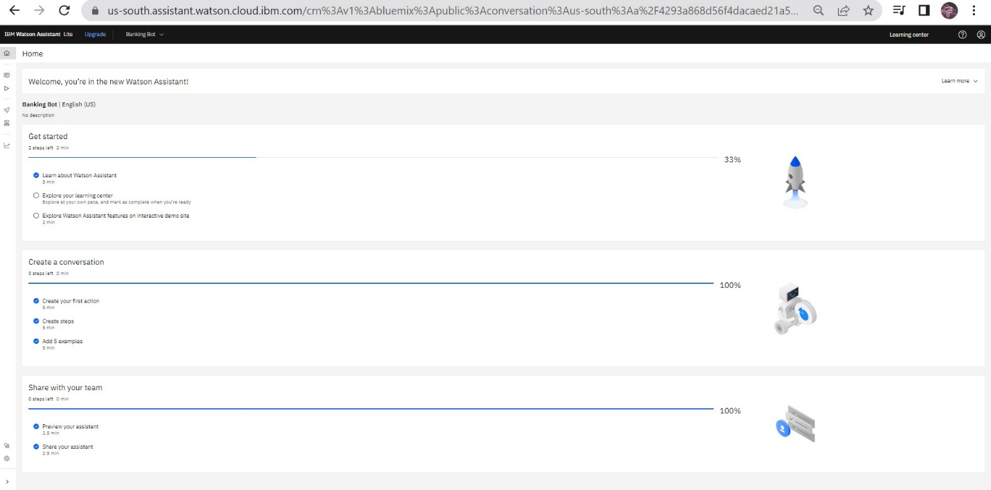

Successfully created IBM Watson Assistant service